**MEETING MINUTES: SUMO DIGITAL GROUP PROJECT**

**Date of meeting:** 13/02/2019

**Time of meetin**g: 10:00 AM

**Attendees**: Dragos Liche, Dawid Hojka, and Anthony Skipwith

**Apologies from:** Alex Butler

**Post-mortem of previous week:**

**What went well:** We have managed to meet all the aims we have set ourselves during the last sprint, thus allowing us to continue developing the game further during this week. The team communication was good, and though people were missing during the few meetings we had, we were notified beforehand, thus making sure we don’t waste time waiting.

**What went badly**: During the meeting, some of the tasks were not correctly logged (they were still logged as in-progress) on JIRA despite being done, which in return made them look unfinished.

**Feedback received**: During the duration of the last sprint, we have not received any feedback.

**Individual work completed:-**

* **Dragos:** Completed the design document and made the mock-up of the bar environment, as well as the external environment, as expected.
* **Dawid:** Completed the style guide and the brief outline form, as well as came up with character concepts, as expected.
* **Anthony:** Got the base for the first-person shooter completed, and researched the reticle movement system, as expected.
* **Alex:** Collected a variety of possible sound assets, as well as referenced all of them. Also did lots of research on the character designs, as expected.

**Overall aim of the current weeks sprint**

The main aim for this sprint from the programmer side is to make sure the reticle movement system works correctly, since it’s our main mechanic. Along with that, start researching enemy pathfinding, so that it can be implemented next week.

From the designer side, the main aim is to start producing the 3D environment and weapon assets, as well as the 2D character assets.

**Tasks for the current week:-**

* **Dragos:** The main task for Dragos this sprint is to produce two of the weapon assets (the banana and the hydrant) in 3DS Max.
* **Dawid:** The main task for Dawid this sprint is to take the character concepts and recreate them in Adobe Illustrator, so that they can be ready for animation. Also design some more concepts.
* **Anthony:** The main task for Anthony this sprint is to implement the reticle movement system into the game, as well as make sure it works correctly, since it’s our main mechanic. Once that is completed, his next task is to start researching enemy pathfinding and how NavMeshes work in Unity, as well as making sure the 2D enemies will always face the player. He also needs to make sure all of the systems are combined together into one game project, so that we can avoid any merging issues in the future.
* **Alex:** The main task for Alex this sprint is to research furniture that could go into the bar environment. Once the research and moodboards are complete, his next task is to create the low-poly 3D assets for a table and a stool, based on his research.

**Meeting ended:** 10:40 AM

**Minute taker:** Dawid Hojka

**Discord Discussion Documentation:**

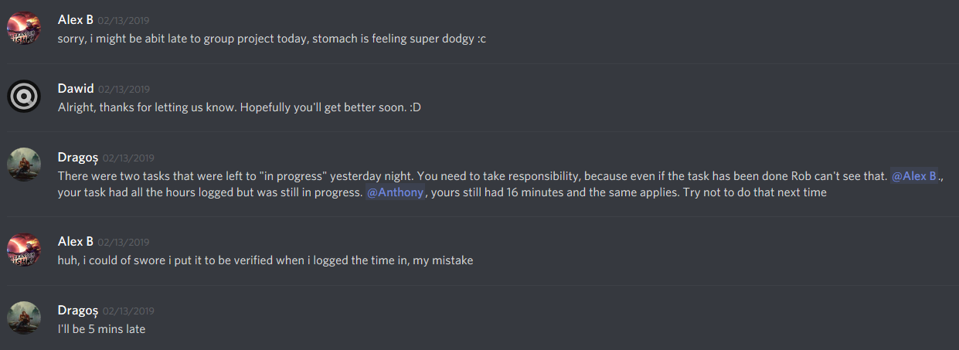

Screenshot 1 - Alex letting us know he might be late to the meeting, as well as a reminder of updating the tasks on JIRA.

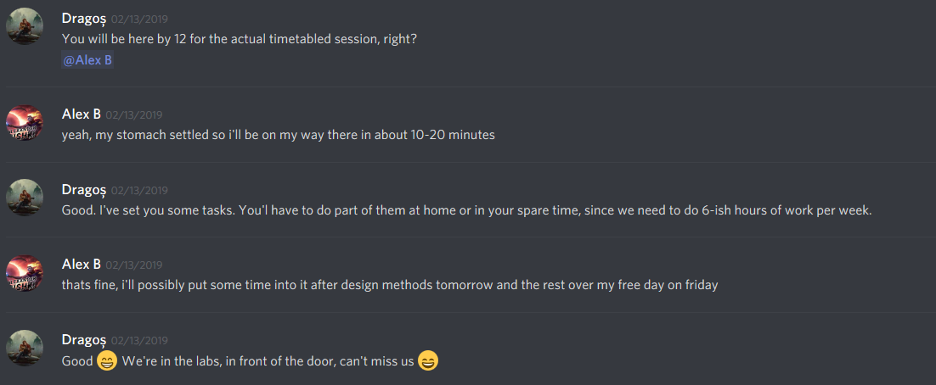

Screenshot 2 - Alex letting us know that he was better and that he will be here at 12:00.